**1. Consider the strategy used by Century 23 Global Fund. What key criteria should Crowley apply when making her investment decisions?**

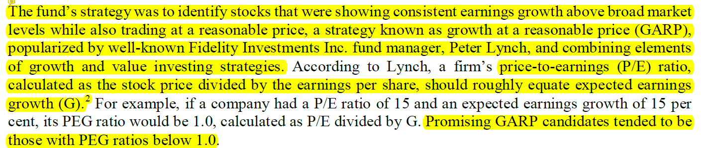

* PEG ratio = (P/E) ratio / G : if PEG ratio < 1 => company might be a promising GARP candidate.
* Company Earnings Growth - Disney’s revenue is above broad market levels (ver folha ‘Calculations’ da spread).
* Competitor Earnings Growth - Both Netflix and Comcast have a revenue growth above broad market levels.
* Stock price - trading at reasonable price

The 'PEG ratio' (price/earnings to growth ratio) is a valuation metric for determining the relative trade-off between the price of a stock, the earnings generated per share (EPS), and the company's expected growth.

In general, the P/E ratio is higher for a company with a higher growth rate. Thus, using just the P/E ratio would make high-growth companies appear overvalued relative to others. It is assumed that by dividing the P/E ratio by the earnings growth rate, the resulting ratio is better for comparing companies with different growth rates.

PEG is a widely employed indicator of a stock's possible true value. Similar to PE ratios, a lower PEG means that the stock is undervalued more. It is favored by many over the price/earnings ratio because it also accounts for growth.

The PEG ratio of 1 is sometimes said to represent a fair trade-off between the values of cost and the values of growth, indicating that a stock is reasonably valued given the expected growth. A crude analysis suggests that companies with PEG values between 0 and 1 may provide higher returns

A PEG Ratio can also be a negative number if a stock's present income figure is negative (negative earnings), or if future earnings are expected to drop (negative growth). PEG ratios calculated from negative present earnings are viewed with skepticism as almost meaningless, other than as an indication of high investment risk.

**2. Size up the economy, as well as the media and entertainment industry. What are the growth prospects, competitive position, and key success factors?**

**Growth Prospects**

Revenue from the M&E industry is expected to grow 4.3 percent annually, reaching 2.3$ trillion in 2020.

Industry is being reshaped by mergers and acquisitions. Disney acquired Twenty-first Century Fox, Inc which enabled Disney to accelerate its direct-to-consumer strategy and expand its global presence. These mergers are expected to contribute to changing consumer streaming behaviors and are also intended in part to build stronger brand loyalty.

**Media Networks**

* Tv subscription revenue was expected to fall by 2.9 per cent annually to $81.8 billion by 2023
* Global revenue from the video streaming sector was forecast to increase 4.2 per cent annually to $28.2 billion by 2023, which would account for 16 per cent of the digital media market. The number of users in the subscription video on demand segment was estimated to grow by 5 per cent annually to 1.3 billion by 2023

**Parks and Resorts**

* The spending on theme parks had recently been increasing at an annual rate of 5 per cent globally to $44.8 billion. According to a 2014 research report about the experience economy, 78 per cent of millennials chose to spend money on desirable experiences or events over buying desirable physical objects
* Recent worldwide park attendance was 1.1 billion and was expected to grow at an annual rate of 3.8 per cent through 2022

**Studio Entertainment**

* The global film industry had experienced steady growth over recent years.
* Industry revenue grew 3.8 per cent in 2019 to $103 billion
* Owning to numerous blockbusters that galvanized the global box office and led to fierce competition, global box office revenue was forecast to increase at an annual rate of 9 per cent in 2020, although it was challenging to predict hit movies.

**Competitive Position**

The battle between streaming services and regular TV providers has been becoming more intense, as people are shifting from watching traditional cable TV to the personalized media content offered by streaming platforms. This has forced TV subscription providers to innovate in order to stay competitive, by delivering 4K quality, advanced boxes, among others. Despite the traditional TV segment’s best efforts, the battle is being won by the streaming platforms, which are growing at great rates while traditional cable TV providers are struggling to grow.

The rise of streaming services has also threatened the studio entertainment industry. Streaming platforms like Netflix have been financing original streaming movies which have started to gain recognition by the traditional film industry.

Regarding theme parks, the rise of popularity of these parks among millennials has raised interest from multiple companies in this segment. Many parks are being built or renovated worldwide. This rush to invest in this segment increases the competitiveness of the parks.

**Key Success Factors**

The decline in traditional cable TV audiences is a major success factor for Disney since the company is betting heavily on the streaming segment with their platforms Disney+, ESPN+ and Hulu. Since the TV and the streaming segments share the same audience, for the streaming segment to grow, the TV segment has to shrink.

One other important factor is the economic status of the US. Although the chance of a crisis recession occurring is low, at 26%, there is still the possibility it might happen. This would be bad for Disney since most of its revenue comes from the US market.



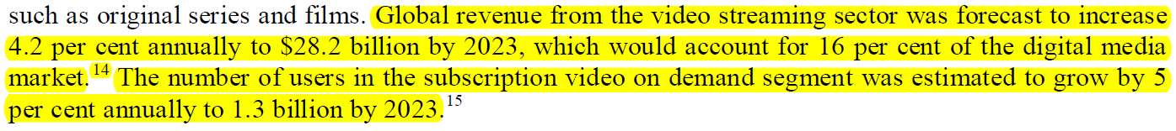

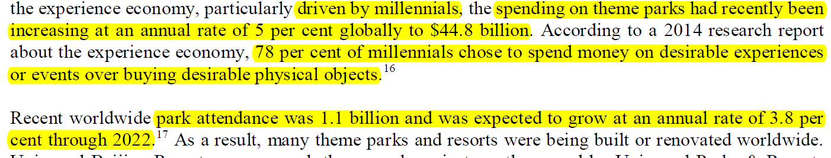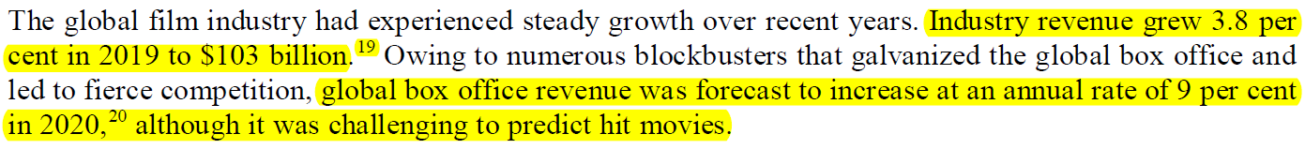

**3. How would you evaluate Disney’s financial performance, both on an absolute basis and relative to its peers?**

**Absolute Basis**

Disney is a company with a very high valuation (302 billion dollars in 2019). Its profit margins are good, even though they have been decreasing since 2017. The gross profit margin has decreased from 45% to 39% and the net profit margin from 16% to 15.8%. The company has recently (in 2019) achieved a negative cash conversion cycle, which means that the company takes longer to pay suppliers than to sell the inventory, which means the suppliers support the company’s operations since they can be paid with the money generated from selling the product they produced. This leads to an increase in working capital, which had been negative in 2017 and 2018, but saw a great increase in 2019. Having more working capital means the company can operate more freely and with more flexibility. From the current ratio, which has been increasing since 2017 and is now at 1.07, we see that the balance between the company’s short-term assets and obligations is controlled and Disney could, if needed, pay its short-term obligations using its short-term assets, avoiding bankruptcy. However, from the quick ratio, currently at 0.80, we conclude that to cover all the short-term obligations, the company relies on assets that might not be easily converted into cash in the short-term, like its inventory. In the general sense, the company’s value greatly increased in 2019 (valuation from 193 to 302 billions, total assets from 98 to 193 billions and total equity from 53 to 102 billions). This probably happened due to the acquisition of TFCF. However, we can also derive from the financial statements that the company suffered some operating income loss after the acquisition (due to TFCF’s consolidation).

**Relative to peers**

Compared to its competitors, Disney has the highest net profit margin, even though its gross profit margin is only the third best. This reveals Disney’s capacity of selling a lot of products while not spending as much on operating expenses as its competitors. Furthermore, Disney is also the company with the highest working capital in 2019. The inversion of the cash conversion cycle in that year has probably led to the company accumulating working capital.

Disney has a valuation almost three times bigger than its major competitor, Netflix, and a much lower P/E ratio. Regarding growth, we can see (statement of cash flow) that Netflix relies on financing to grow (cash from financing is, 4335 in 2019), while Disney relies mostly on its own investments and operating income to support its operations. With its higher net profit margin and diversified operations, Disney is able to obtain a higher net income than Netflix. While Disney obtained a net income of 15.9% of all its revenue in 2019, Netflix was only able to achieve 7.5% in the same year. However, Netflix has been showing bigger growth margins than Disney. Netflix’s net income grew 194% from 2017 to 2018 and 16.7% the next year, while Disney’s showed values of 40% from 2017 to 2018 and -12.3% the next year. Overall, Netflix is showing signs of fast growth, but with more volatility and instability, while Disney, being a bigger company, is growing more slowly, but betting on the long term (buying new assets, like TFCF).

Viacom is a smaller company than Disney and relies on having cash to fund its operations, since its cash conversion cycle is around 121 days. It looks like the company is choosing a conservative growth approach, having both its current and quick ratios above 1 (they could easily pay all their short-term liabilities if needed). This ensures the company will not go into bankruptcy in case of a disaster, but it also means it is not using its assets to their full potential of generating more revenue. It is the only company with a revenue growth below the industry standard level.

Comcast is a company with a similar valuation to Disney’s. The company’s growth strategy looks to be quite aggressive, having both the quick and current ratios below 1. From the company’s balance sheet we can see that Comcast has a lot of debt, more than twice Disney’s debt value, but less equity. Both companies had similar net incomes in 2019. However, with Disney’s higher net profit margins, its net income was generated from less revenue, meaning that if both companies were to have generated the same revenue in 2019, Disney’s net income would have been quite bigger than Comcast’s.

Disney and Viacom have the lowest PEG ratios among the four companies, meaning their stocks may be undervalued, while the others might be overvalued.

**4. How would you assess Disney’s prospects compared with the consensus analysts’ forecasted revenue and profits? How would you assess the future performance of its peers?**

From the forecasted revenue and profits, we can see that Disney is expected to continue its upward trend in revenue generation. In 2020, it is expected to generate 17.53% more revenue than in the previous year and 6.06% in 2021. The reason for the growth in 2020 being bigger is that the financial consequences of the TFCF acquisition will, by then, be overcome and Disney will start to generate revenue from TFCF. Both the company’s Enterprise Value to Revenue ratio and the Price to Earnings ratio will also start to stabilize in 2020 and 2021, meaning the stocks' prices will approach their actual value. Although Disney is expected to suffer a loss in net income in 2020, decreasing around 21% compared to the previous year, it is expected to bounce back in 2021 with a net income growth of 16.6%.

Compared to its competitors, Disney is expected to be passed by all the others regarding its net income margin, even though it is expected to have the second-highest revenue growth in 2020 and 2021, only being passed by its biggest competitor, Netflix. Netflix will continue to see big increases in net income, continuing to net less income than Disney on an absolute basis, and will start to stabilize its stock price. Both Comcast and Viacom will achieve similar growth values, but on two very different scales. Viacom, as a smaller company, is expected to continue its conservative growth strategy, opting to grow slowly but steadily.

**5. In the place of Crowley in December 2019, what action, if any, would you take with respect to the Century 23 Global Fund’s position regarding Disney’s stock? Defend your position.**

After an extensive financial analysis, we concluded that Disney’s stock is a good long-term investment. Disney’s PEG ratio is less than 1, which is one of the most important factors for the fund’s investment strategy, and the company has also been showing growth values above the broad market levels. While the industry standard is 4.3% of revenue growth per year, Disney has been achieving higher values, obtaining 7.79% growth in 2018 and 17.05% in 2019. In the short-term, Disney might suffer from some instability derived from the TFCF acquisition, but this should prove to be an important long-term investment for the company, as it’s expected to increase Disney’s value and revenue generation.